


BOND

Blessing Our Neighbours Delightfully
Proposal Submission 2026

What are Joyful Centre and BOND about?
- Joyful Centre serves as VCEFC’s doorway for connecting our multilingual congregations with our multicultural neighbourhoods. Its primary goal is to make neighbourhood care part of the church’s everyday mission. It promotes our neighbourhood ministries and provides our congregants with opportunities to develop and participate in them.
- BOND stands for “Blessing Our Neighbours Delightfully.” This initiative is designed to streamline the process of submitting neighbourhood ministry proposals and to minimize the administrative burden on participants. By handling logistical tasks such as registration, facility booking, scheduling, and community promotion, BOND allows ministry teams to focus time and energy on their primary purpose: blessing our neighbours delightfully.

How to submit a proposal? (3 steps)
Step #1 Answer 4 simple questions: (a.k.a. the MAPS for ministries)
- Mission: What purpose are you fulfilling?
- Passion: Who do you long to serve first?
- Situation: Which of their needs could or should you address?
- ACTION: How are you going to respond?
Step #2 Share it with Pastors & Congregation Committee for guidance & review
Step #3 Submit it to Missions Department (Joyful Centre) for approval & support: Joyful@vcefc.org

Before submitting for approval, please complete the following items:
- Proposal was reviewed by: Date: .
- Proposal was submitted by: Date: .
Contact email: .
Contact phone no.: .
Other team members: .
Mission: What purpose are you fulfilling?
- Prayerfully reflect on and clearly articulate the mission entrusted to you in relation to VCEFC’s goal of blessing our neighbours delightfully.
- You may consider using the following materials and tools for your preparation:
  - VCEFC Mission Statement & Yearly Theme / Group or Ministry Team Mandates / Roles & Responsibilities, etc.
Your Answer :
Click here to type

Passion: Who do you long to serve first?
- Prayerfully reflect on and clearly articulate the particular people group you believe God is leading you to serve first, for the purpose of blessing our neighbours delightfully.

Your Answer :
Click here to type

Situation: What needs could or should you address?
- Prayerfully reflect on and clearly articulate the specific needs of our neighbours that you seek to address, taking into account the context in which our church is placed and the resources and responsibilities entrusted to us.
- You may consider using the following tools for your preparation:
  - 3x4 Discipleship Pathway, Appreciative Inquiry, SWOT analysis (Strengths, Weakness, Opportunities, and Threats), Urgent–Important Matrix, etc.
Your Answer :
Click here to type

ACTION: How are you going to respond now?
- Prayerfully reflect on and clearly articulate the fitting responses you plan to carry out, for the purpose of blessing our neighbours delightfully.
Your Answer :
Click here to type

Other Comments
Your Answer :
Click here to type

VCEFC Mission Statement
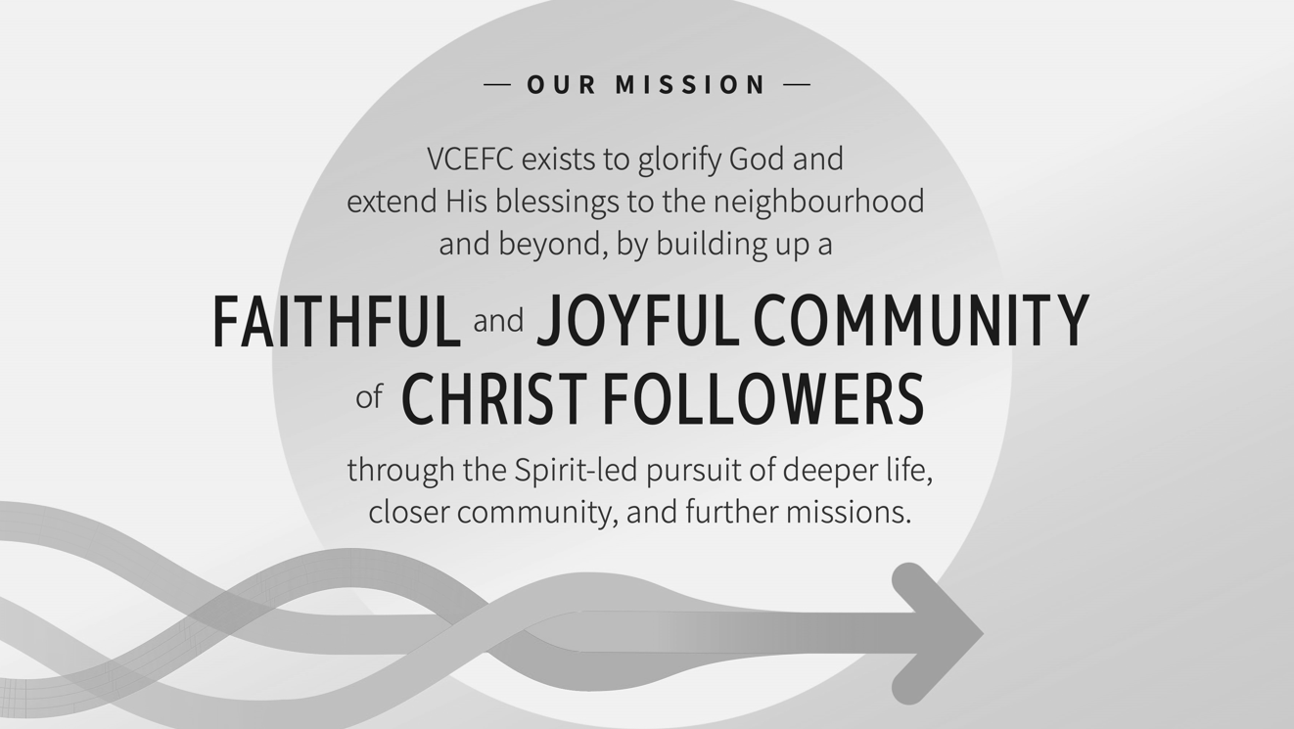
2026 & 2027 VCEFC Theme
